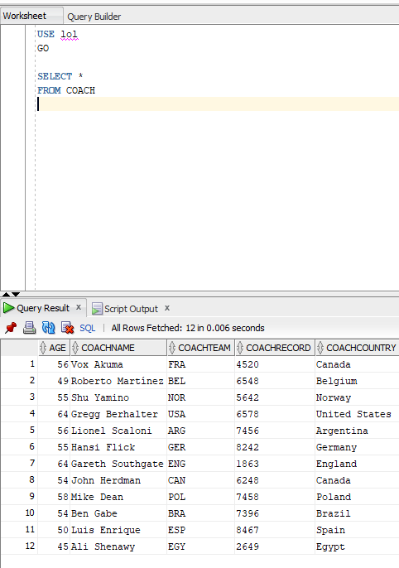

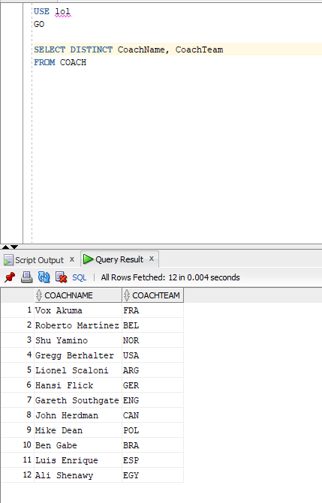

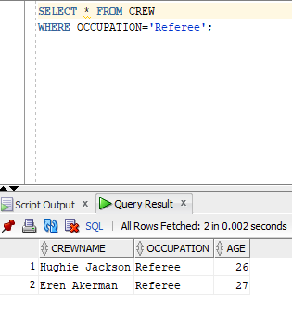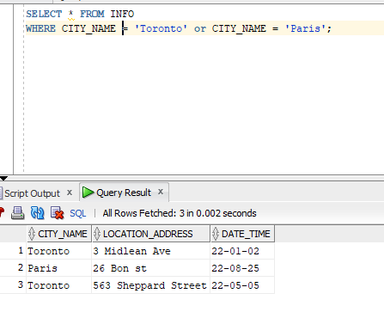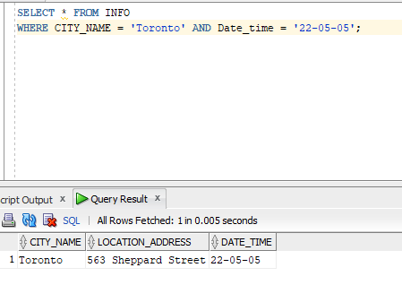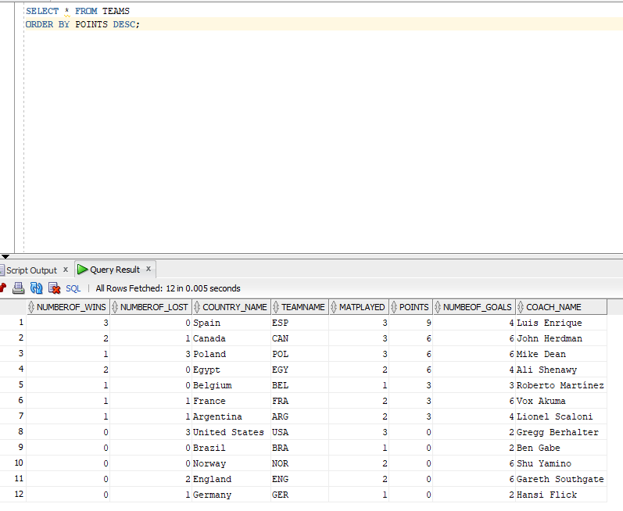

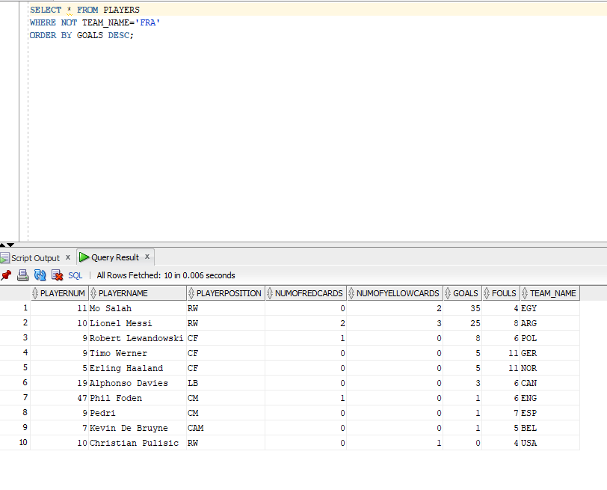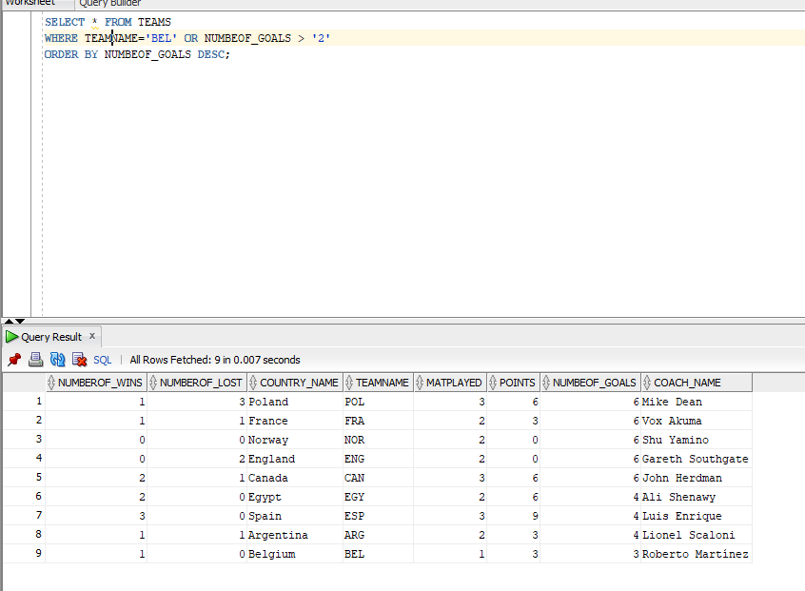

Join Queries

Views

